CMSC 204
Huffman Lab

- Create a Huffman Tree and generate the codes for each character of the following input:
create a huffman tree
For consistency:
- If same frequency – put in priority queue alphabetically; put space before other characters of the same frequency

Counting how many times each character appears in the input “create a huffman tree”

The character frequencies are:
a: 4
e: 3
r: 2
t: 2
f: 1
h: 1
m: 1
n: 1
u: 1
c: 1
space: 3

- Add subtrees to end of group with same priority

The subtrees with the same priority queue are,
1: c, f, h, m, n, u
2: r, t
3: space, a, e

- Lower number has higher priority (goes to front)

(1, 'c')
(1, 'f')
(1, 'h')
(1, 'm')
(1, 'n')
(1, 'u')
(2, 'r')
(2, 't')
(3, ' ')
(3, 'e')
(4, 'a')

Huffman Codes:
c: 0000
f: 0001
h: 0010
m: 0011
r: 0100
t: 0101
n: 1000
u: 1001
(space): 101
e: 1100
a: 1101

Final encoded string:
00000100110011010101110010111011010010100100010001001111011000101010101001100110

- Based on the following Huffman tree and binary sequence, what is the text

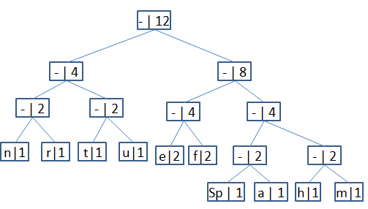

1110011101101111111010001100010001100100

Using the provided Huffman tree, the decoded characters are:
h → 1110
u → 011
u → 011
t → 010
m → 1111
h → 1110
e → 100
u → 011
n → 000
e → 100
(space) → 1100
e → 100
Final Decoded Message:
huutmh eunee

